To Be – Interrogative and negative
Interrogative She is twenty-five years old.
Form
Is she twenty-five years old?

Negative Form She isn’t twenty-five years old.

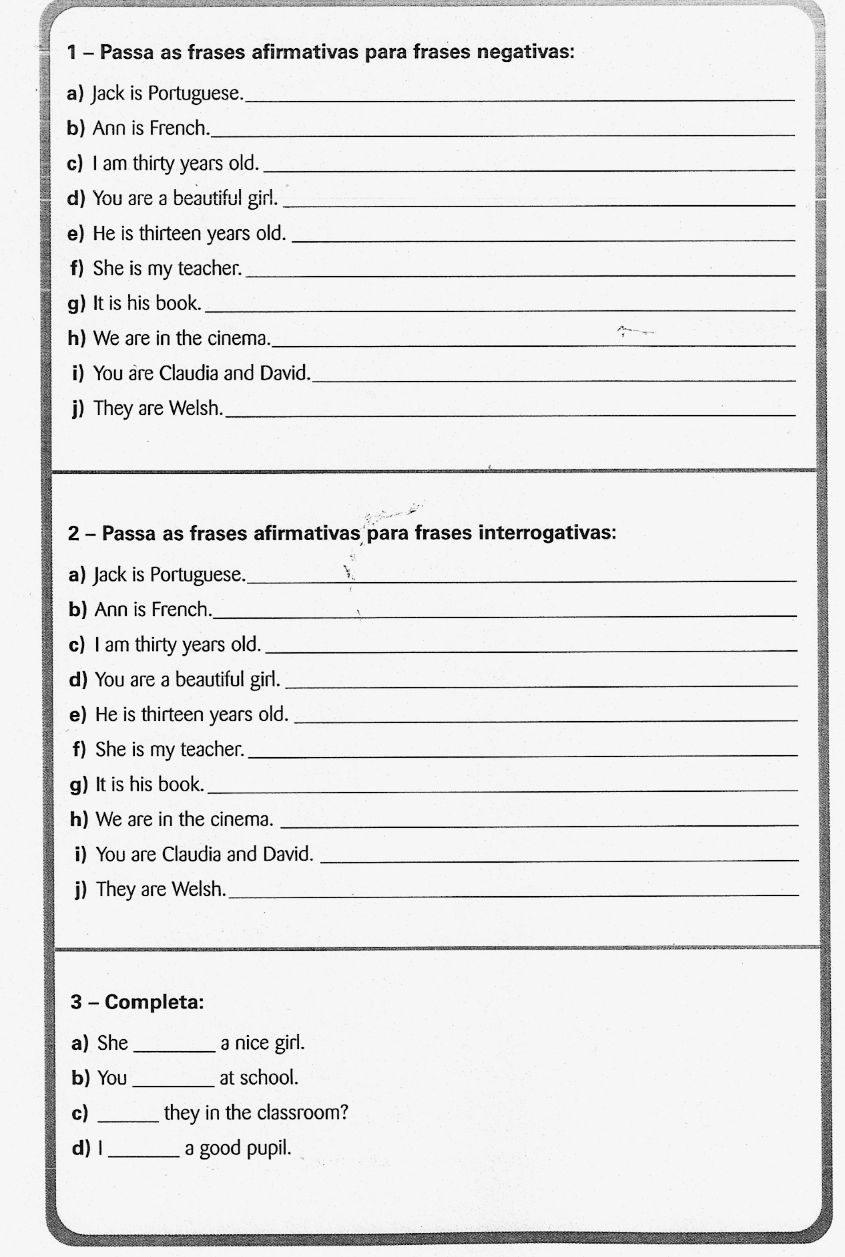
1. Rewrite the sentences in the negative form.
2. Rewrite the sentences in the interrogative form.
3. Complete.
To Have got- Interrogative and negative
2. Rewrite the sentences in the interrogative form.
3. Complete.

Interrogative She has got a green bike.
Form
Has she got twenty-five years old?

Negative Form She hasn’t got a green bike.

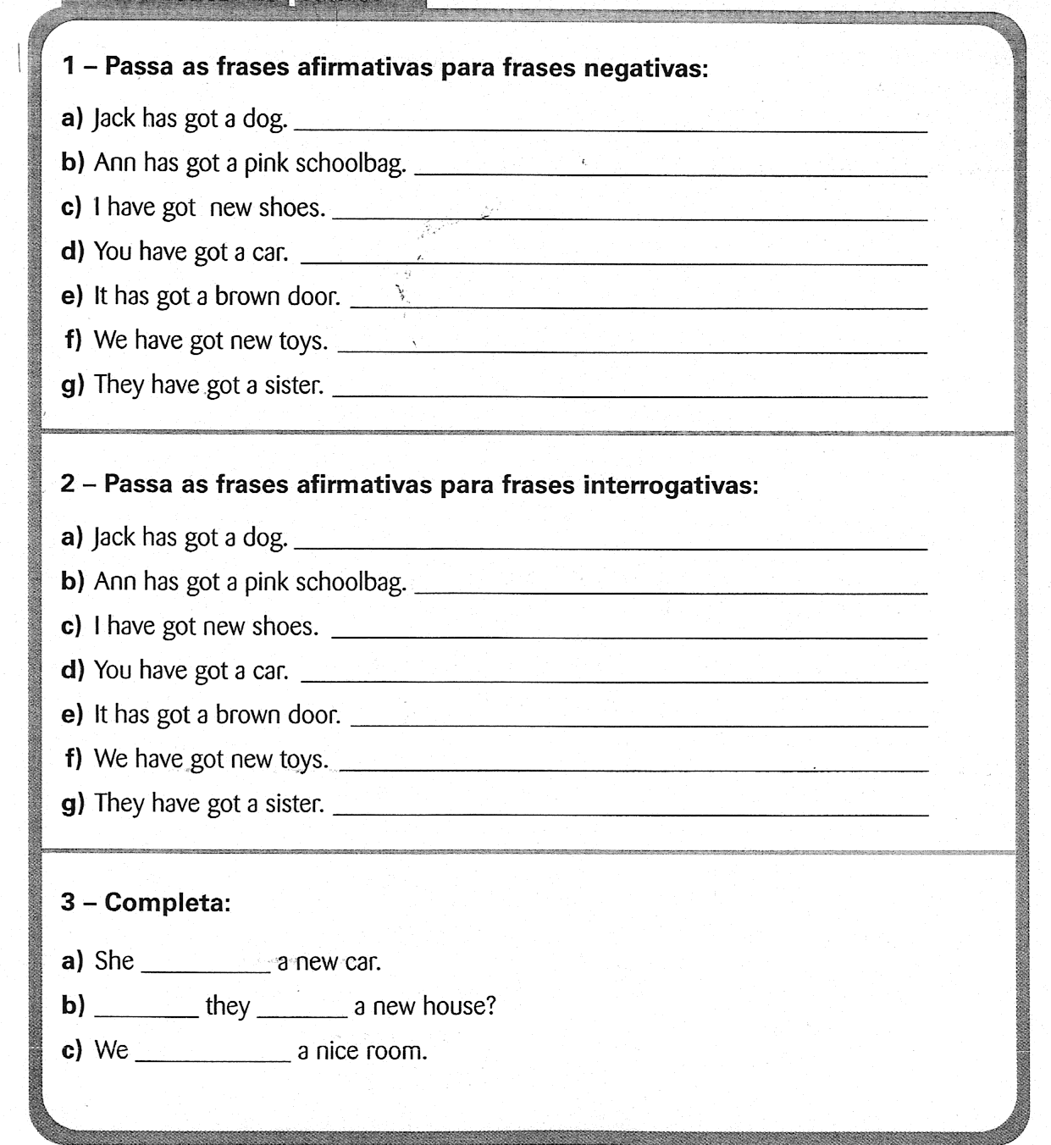
1. Rewrite the sentences in the negative form.
2. Rewrite the sentences in the interrogative form.
3. Complete.

Interrogative and negative with To Do
2. Rewrite the sentences in the interrogative form.
3. Complete.

Interrogative She likes strawberries.
Form
Does she like strawberries?

Negative Form She doesn’t like strawberries.

1. Rewrite the sentences in the negative form.
2. Rewrite the sentences in the interrogative form.
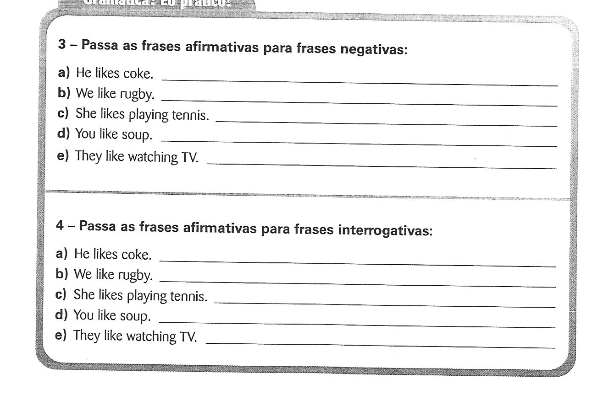
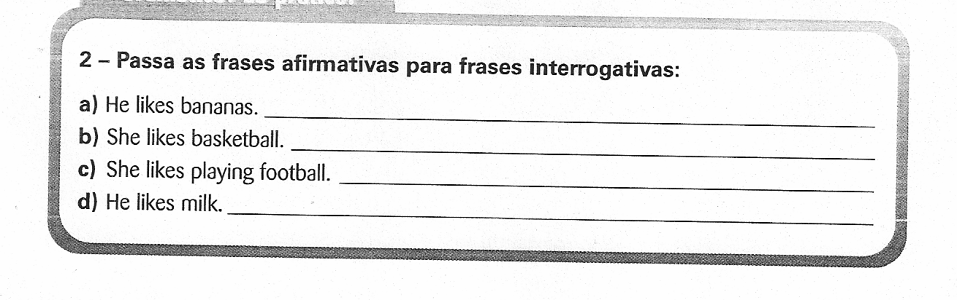
3. Rewrite a few more sentences in the interrogative form.

Correction

- a) He doesn’t like coke.
b) We don’t like rugby.
c) She doesn’t like playing tennis.
d) You don’t like soup.
e) They don’t like watching TV.

- a) Does he like coke?
b) Do we like rugby?
c) Does she like playing tennis?
d) Do you like soup?
e) Do they like watching TV?

3.a) Does he like bananas?
b) Does she like basketball?
c) Does she like plying football?
d) Does he like milk?

