ALL SAINTS’ CHURCH WHITSTABLE

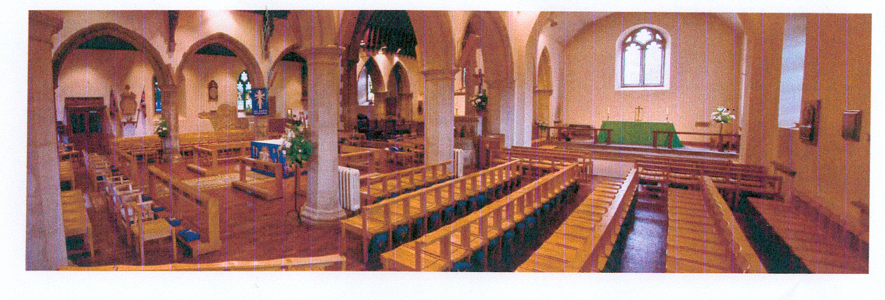

VIEW FROM WEST END OF SOUTH AISLE

