DRAFT

What is CSG?
Citrix Secure Gateway is a software feature for both Citrix XenApp and XenDesktop that allows simple proxying of ICA connections over SSL from a network of clients (typically WAN users) to a set of internal resources (a XenApp or XenDesktop farm). This feature runs on Windows Server and is typically assigned an external IP, so will usually be found in the DMZ. Citrix appears to be positioning away from this platform in favor of a virtual appliance of the CAG.

What is a CAG?
Citrix Access Gateway is a hardware appliance or virtual machine appliance of the CSG. In addition to the CSG features, the CAG appliance can act as a general purpose SSL VPN solution with the ability to proxy protocols other than ICA
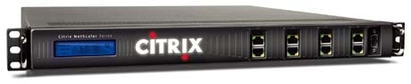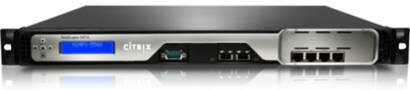
  - Editions
- CAG Standard – available as a hardware appliance or virtual machine appliance
  - Model 2010 or VPX
- CAG Advanced – available as a hardware appliance or virtual machine appliance
  - Model 2010 or VPX
- CAG Enterprise – available as a hardware appliance
  - MPX 5500

What is a NetScaler?
The Citrix NetScaler is also a hardware appliance with additional enterprise features. In addition to the ability to proxy ICA connections over SSL, it is also capable of load-balancing, SSL offloading, content caching, and defensive packet inspection for security threat management. Additionally, while the NetScaler is produced by Citrix it is capable and fully supported to load-balance non-Citrix resources (Apache or IIS servers, VMware View, RDS/RDP, etc).
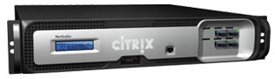
  - Editions
- NetScaler Standard – available as a hardware appliance or virtual machine appliance
- NetScaler Advanced – available as a hardware appliance or virtual machine appliance
- NetScaler Enterprise – available as a hardware appliance or virtual machine appliance
NetScaler hardware and virtual appliances are purchased to fit traffic capacity and processing capability. Licensing for standard/advanced/enterprise can be added to the VPX or any of the NetScaler hardware models.

WTOS/Xenith Support for CSG, CAG, and NetScaler
As of Wyse ThinOS 7.X and Xenith X.X, we are successfully able to connect to the following:
- CSG
- CAG Standard
- CAG Advanced
- CAG Enterprise
- NetScaler Standard
- NetScaler Enterprise
- NetScaler Platinum

How to Configure CSG
Fill this in later

How to Configure CAG or NetScaler
- This guide assumes that you have configured authentication on your vServer in one of three ways : authentication on the vServer using RSA, authentication on the vServer using LDAP, or authentication disabled on the vServer (commonly called CSG Mode)
  - This configuration is done in the vServer under the “Authentication” tab
  - When using RSA, your xen.ini (for Xenith) or wnos.ini (for Wyse ThinOS) should have a line such as:
PnliteServer=https://netscaleraddress.domain.com CAGAuthMethod=RSA
  - When using LDAP, your xen.ini (for Xenith) or wnos.ini (for Wyse ThinOS) should have a line such as:
PnliteServer=https://netscaleraddress.domain.com CAGAuthMethod=LDAP
  - When using CSG mode (disabled authentication on your vServer), your xen.ini (for Xenith) or wnos.ini (for Wyse ThinOS) should have a line such as:
PnliteServer=https://netscaleraddress.domain.com
- Go to “Access Gateway”, then “Policies”, then “Session”, and click on the “Profiles” tab
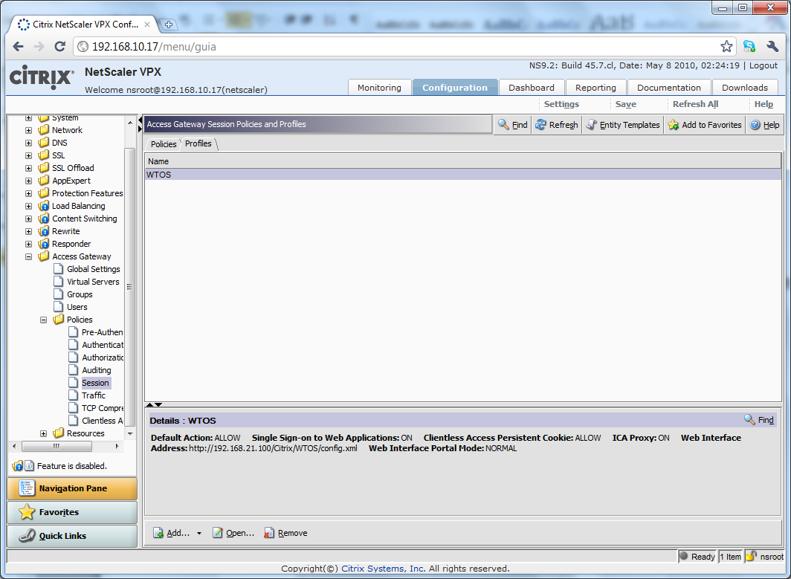
- Create a Request Profile called “WTOS” with the following settings
  - Request Profile – Network Configuration
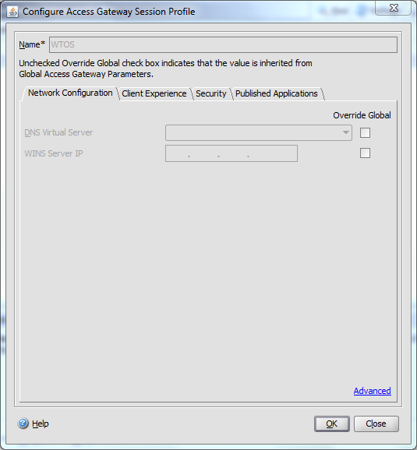
  - Request Profile – Client Experience
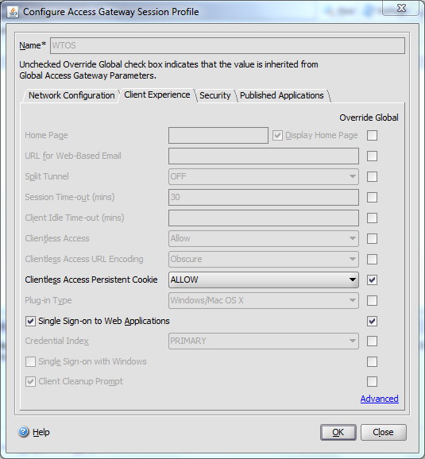

  - Request Profile – Security
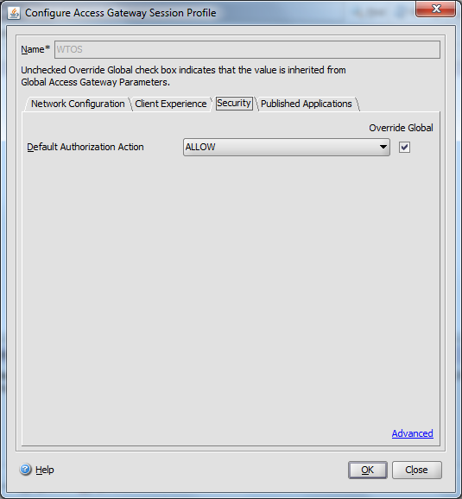

  - Request Profile – Published Applications
    - For “Web Interface Address” enter the correct path to your Web Interface Service Site that is configured for CAG/NetScaler access
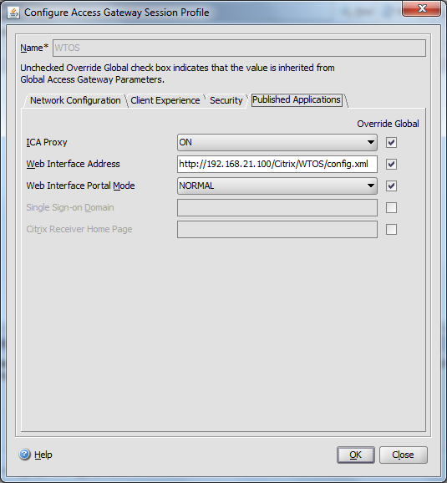
- Go to “Access Gateway”, then “Policies”, then “Session”, and click on the “Policies” tab
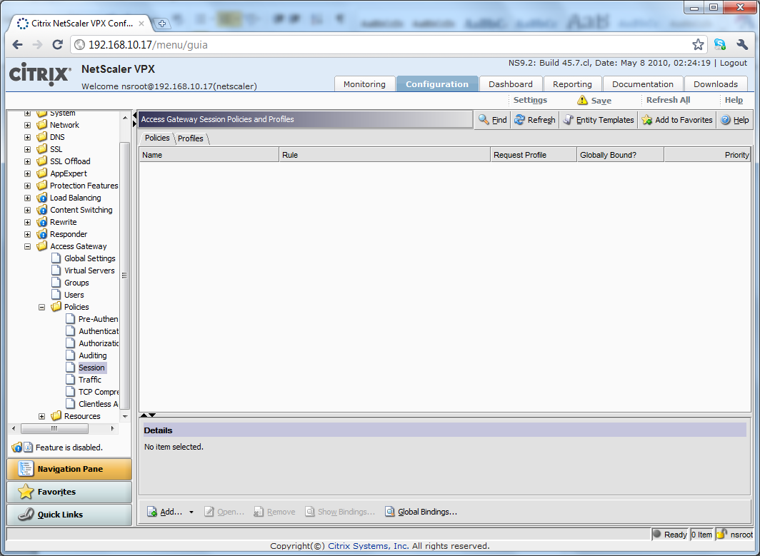
- Click “Add” to create a new policy called “WTOS” and select “WTOS” as the “Request Profile”
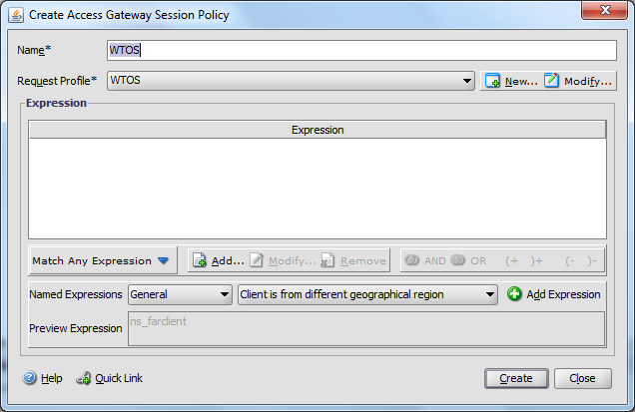
- Click “Add” and enter details as below
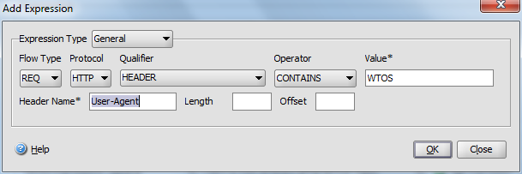
- Click “OK”, then click “Create”, and then click “Close”
- Open the vServer, go to the “Policies” tab, and click “Insert Policy”
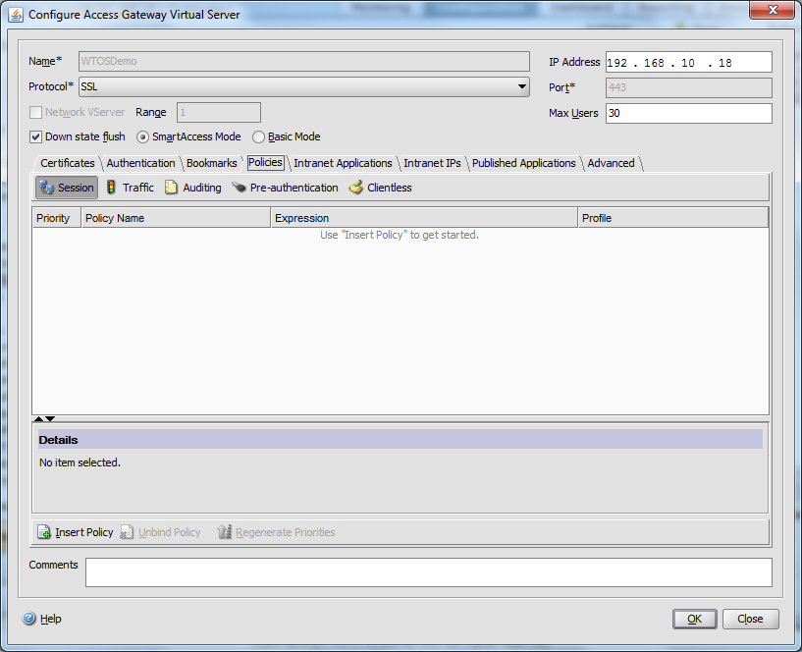

- Select “WTOS” as the “Policy Name” – this will bind the policy and profile we created previously to your vServer
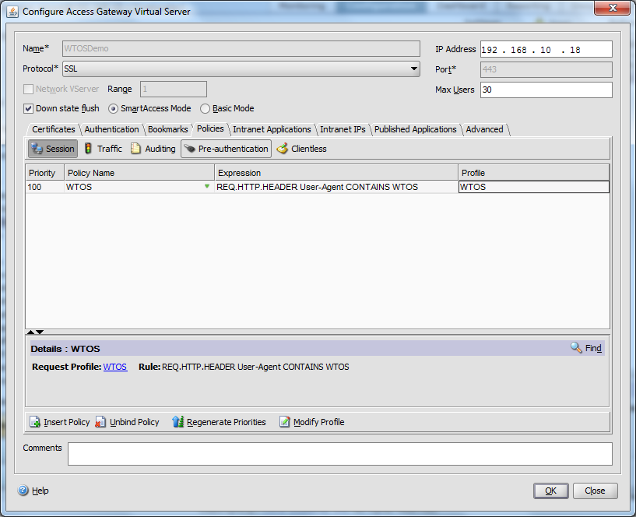
- Click “OK”
- Successfully test a connection from a Wyse Xenith or Wyse ThinOS device

Useful Links
- Download NetScaler VPX
  - http://www.citrix.com/trynetscaler/
- Download Citrix Access Gateway VPX
  - http://www.citrix.com/tryaccessgateway/
- Getting Started with Access Gateway Enterprise Edition 9.1
  - http://support.citrix.com/article/CTX121641
- Getting Started with NetScaler VPX 9.3
  - http://support.citrix.com/article/CTX128668
- NetScaler edition comparison chart
  - http://www.citrix.com/English/ps2/products/subfeature.asp?contentID=2300450
- NetScaler hardware appliance comparison
  - http://www.citrix.com/lang/English/lp/lp_1857713.asp

Common Errors on Xenith or WTOS
- Citrix signon: No such file or directory
  - Access Gateway Session Profile > Security > Default Authorization Action should be set to “Allow”
- SSL: unknown certificate authority!
  - Provide steps on installing the root CA and intermediate certs
- SSL: unable to setup connection {err=7517}
  - Provide steps on installing the root CA and intermediate certs
  - Sometimes a latent error, not reproducible yet. Trying connection again seems to work

