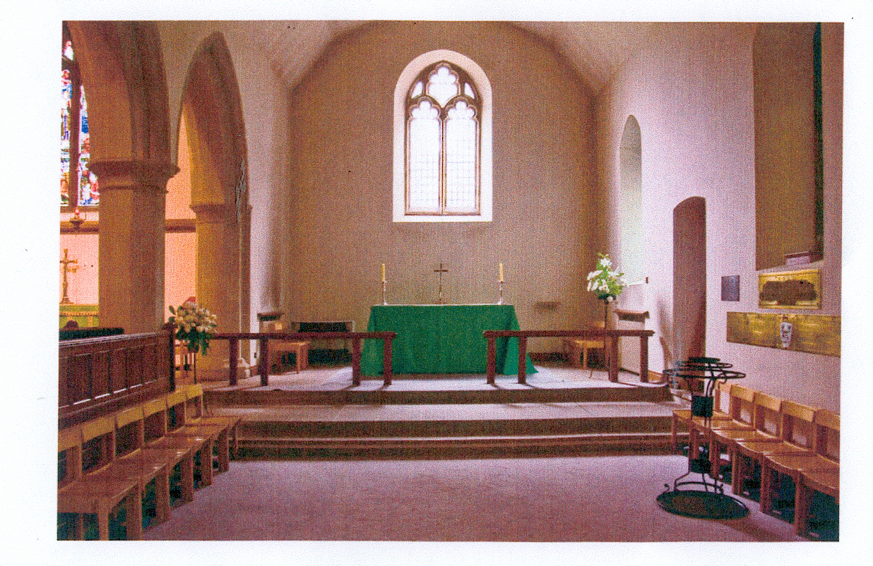
ALL SAINTS’ CHURCH WHITSTABLE

SOUTH AISLE CHAPEL

