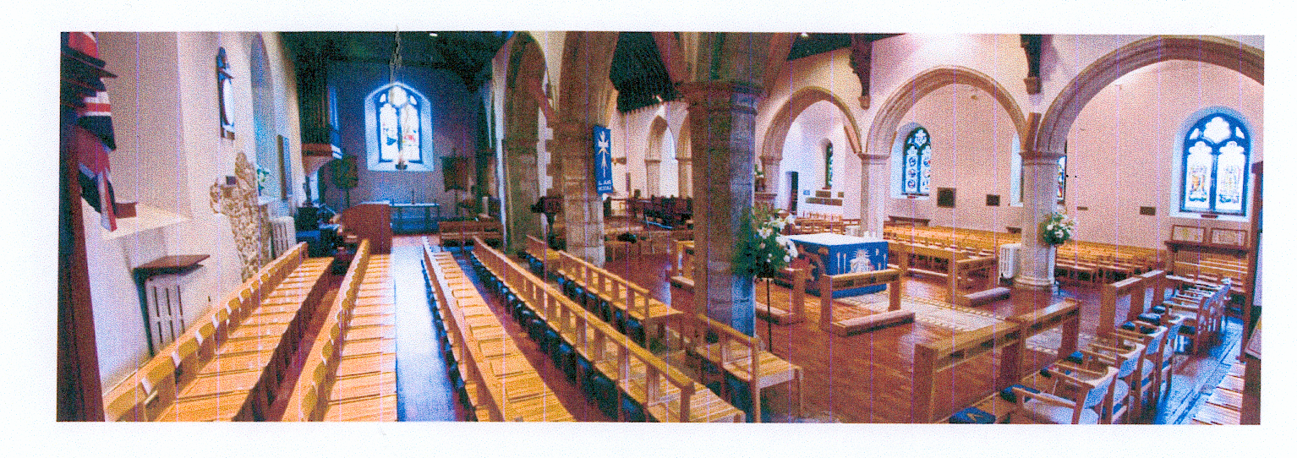
ALL SAINTS’ CHURCH WHITSTABLE

VIEW FROM WEST END OF NORTH AISLE

